Personnel responsible:
Lead Operator, Salt Operator

Safety:
Safety shoes and safety glasses are required when working in the production area.

Summary:
The Dryer Exit Salt Temperature probes need to be checked each day to ensure that the Dryers are not hotter or colder than we think they are.

Procedure:
- Power on the hand help temperature meter by pressing the on/off button. Press the on/off button a second time to get the reading in 10ths.
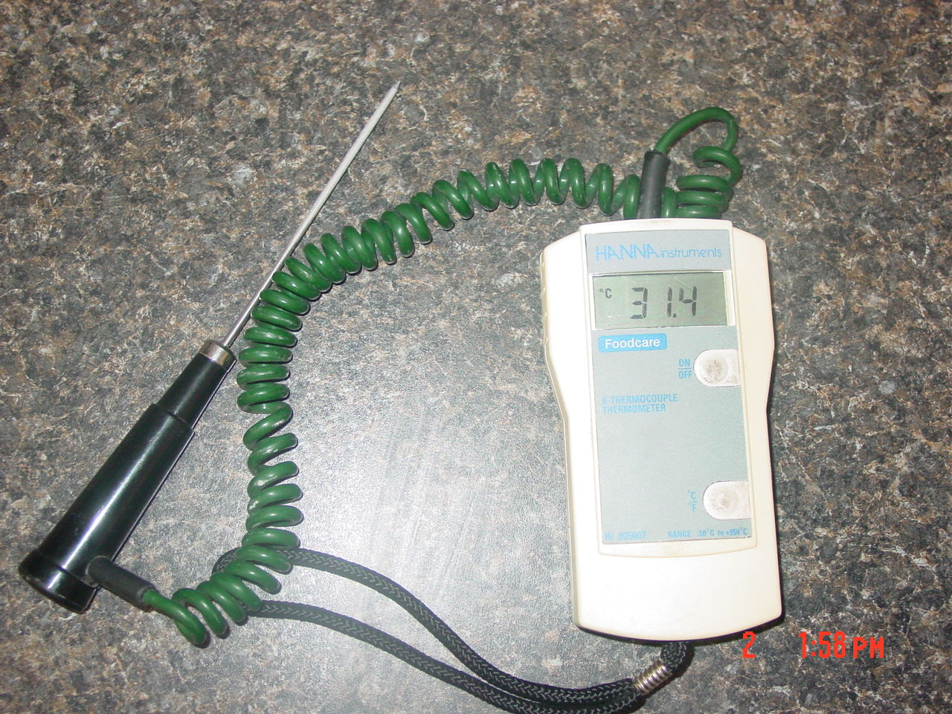

- Find the checking port below the Dryer Exit Salt Temperature probe and flip the cover open.
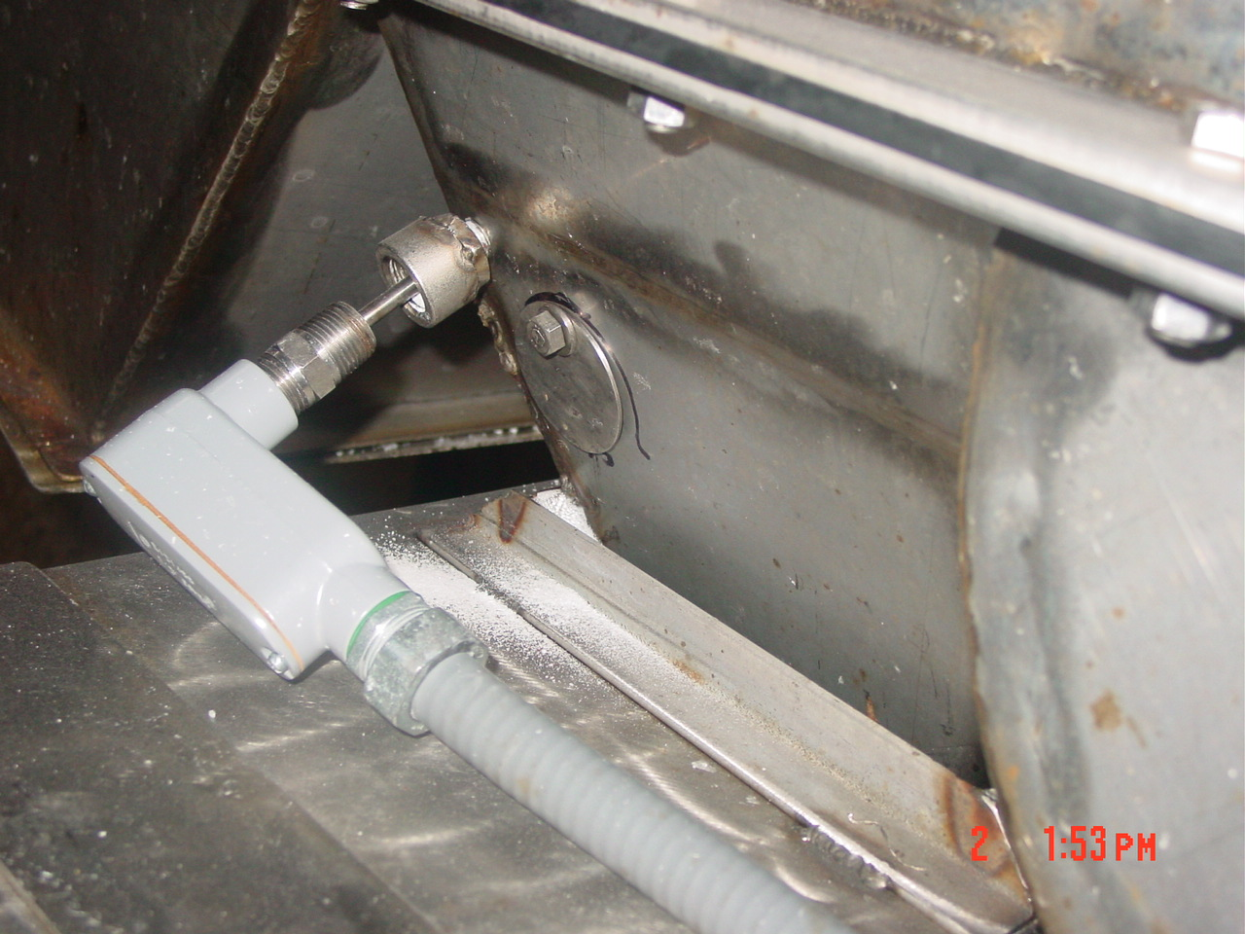

- Insert the probe about half way and angle the probe toward the back of the chute. You should feel the salt falling across the probe.
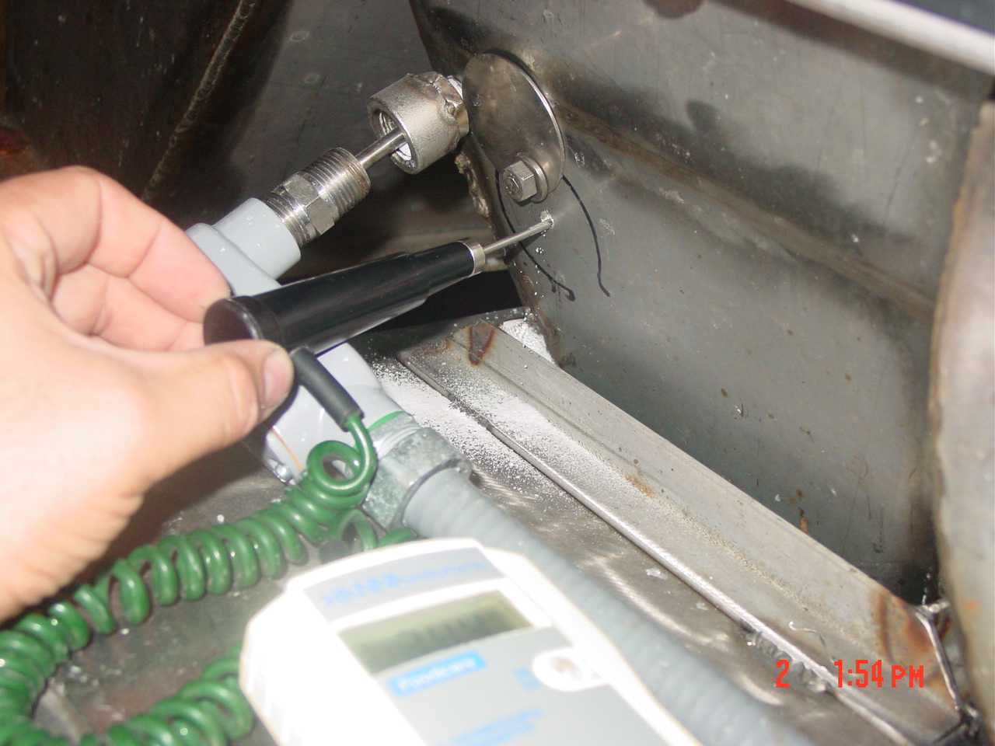

- Wait for 1 full minute, or until the temperature quits climbing, and compare the meter reading to the reading on the dryer.
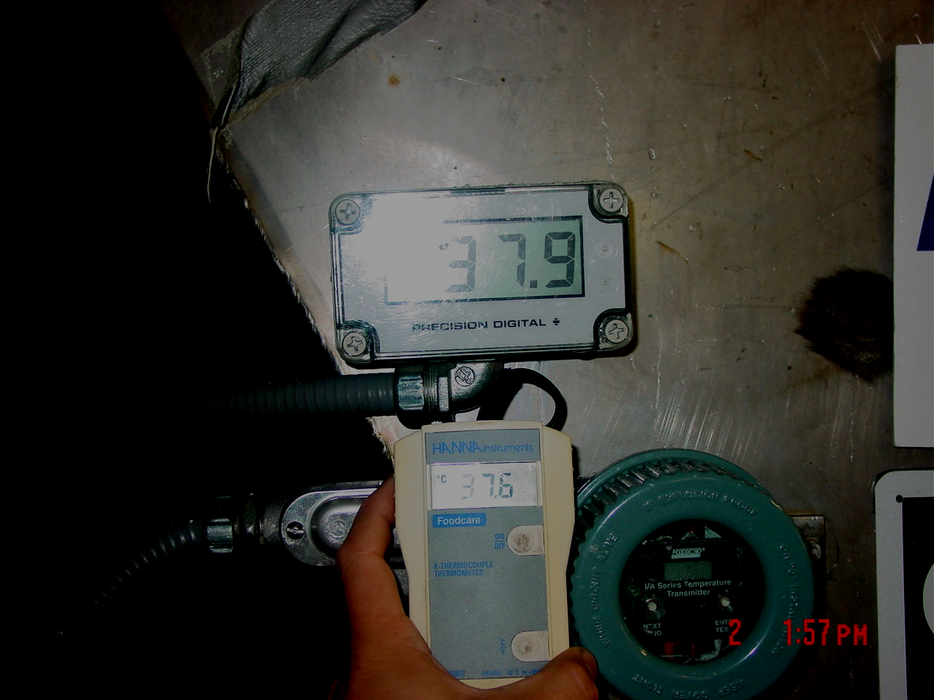

- Record the reading on the Salt Operator Log.
- If the readings disagree by more than 1.0 degrees, make a note on the Shift Log and inform the Lead Operator.
- Repeat steps 2-6 for Dryer #2.
- Turn off the hand held temperature meter by pressing the on/off button.
- Place the meter in the Salt Operator’s desk.

TRAINING DOCUMENTATION

 | EMPLOYEE | TITLE | SIGNATURE | DATE
1
2
3
4
5
6
7
8
9
10
11
12
13
14
15
16
17
18

Revision  Number | Revision  Date | Revision  Author | Revision Description
0 | 9/7/2010 | PLO | Original Document

